Homework 6
- All homework must be turned in on PDF format. This can be scanned or typed in any paper size, but the format must be PDF and the file must be readable. This document can be modified for your homework submission. An additional homework template is available on Canvas to assist you in creating your answers, and content from lecture notes can be used.
- All final answers must be circled or in green.
- All homework must have a name on the top of every page.
- Submission errors (not in PDF, illegible, etc.) will not be re-graded.

Problem 1 (2 pts)
Make the following equation using the minimum number of NAND gates
$$f\left(a,b,c,d\right)=∏M\left(1,3,4,9,14\right)⋅D(0,2,5,6,8,11,12)$$
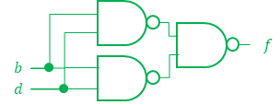
Giving the equation as maxterms is a red herring: using the minimum number of NAND gate implies making a sum-of-products equation is being implemented, which means solving for the minterms.
$$f\left(a,b,c,d\right)=∑m\left(7,10,13,15\right)+d\left(0,2,5,6,11,12\right) \\ =bd+\overline{b}\overline{d}$$
 | $$cd$$
$$ab$$ | d |  |  | d
 |  | d | 1 | d
 | d | 1 | 1
 | d |  | d | 1

Problem 2 (2 pts)
Convert the following circuit into one using only NOR gates (and no inverters). Do not optimize the circuit except for the number of “inverters”.
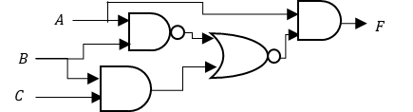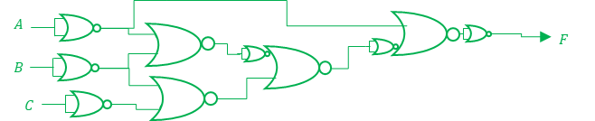

Problem 3 (2 pts)
Create a 3-to-6 active-low decoder with an active-high enable. Name your inputs $\{x_{2},x_{1}, x_{0}\}$ (with $x_{0}$ as the LSB).
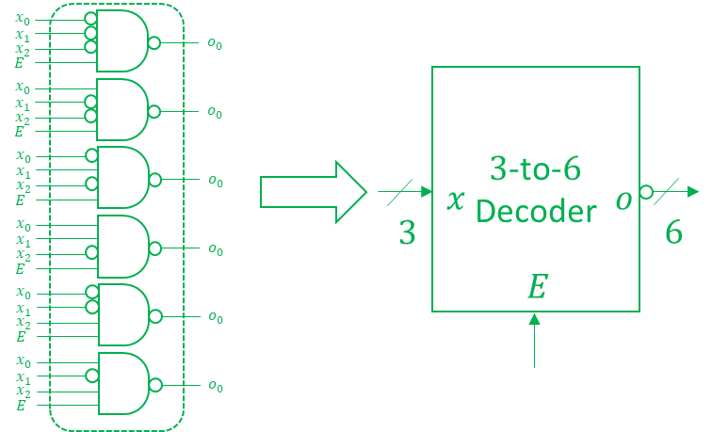

Problem 4 (4 pts)
Design a 3-to-8 active-low decoder using only 2-to-4 active-low decoder modules. No other gate types or modules may be used (you may use constant values). Assume that each 2-to-4 decoder has one active-low enable input, E.
2-to-$4$ Dec.
$$m$$
$$l$$
$$\overline{E}$$
2-to-$4$ Dec.
$$m$$
$$l$$
$$\overline{E}$$
2-to-$4$ Dec.
$$m$$
$$l$$
$$\overline{E}$$
$$A$$
$$0$$
$$B$$
$$C$$
$$B$$
$$C$$
$$0$$
$$A$$
$$B$$
$$C$$

